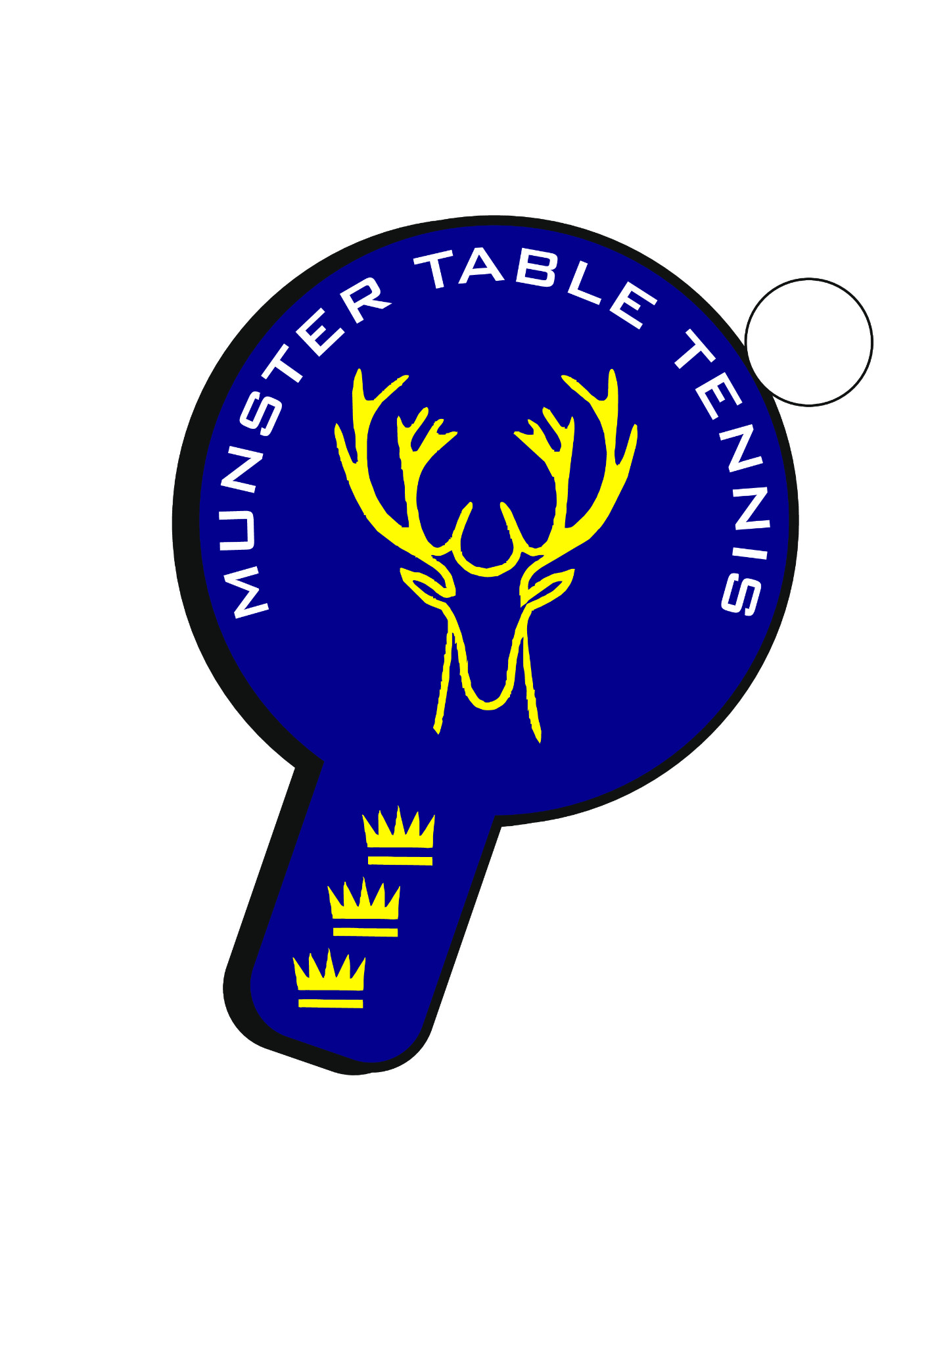

Munster Ranking Tournament No. 4

Competition Report

Introduction
The fourth Munster Ranking Tournament of the 2025/26 season was successfully staged on Sunday, 22 February 2026 at Kingfisher Hall, Waterford. Hosted by TTStars Waterford on behalf of the Munster Branch, the event attracted a healthy entry of 87 players competing across twelve categories.
The tournament featured a full programme of Junior, Senior, Para and Veterans events, with a high standard of play evident throughout the day.
Kingfisher Hall proved to be an excellent venue, comfortably accommodating the large schedule of matches along with strong support from spectators and families. The on-site café was busy throughout the day and was well received by attendees.

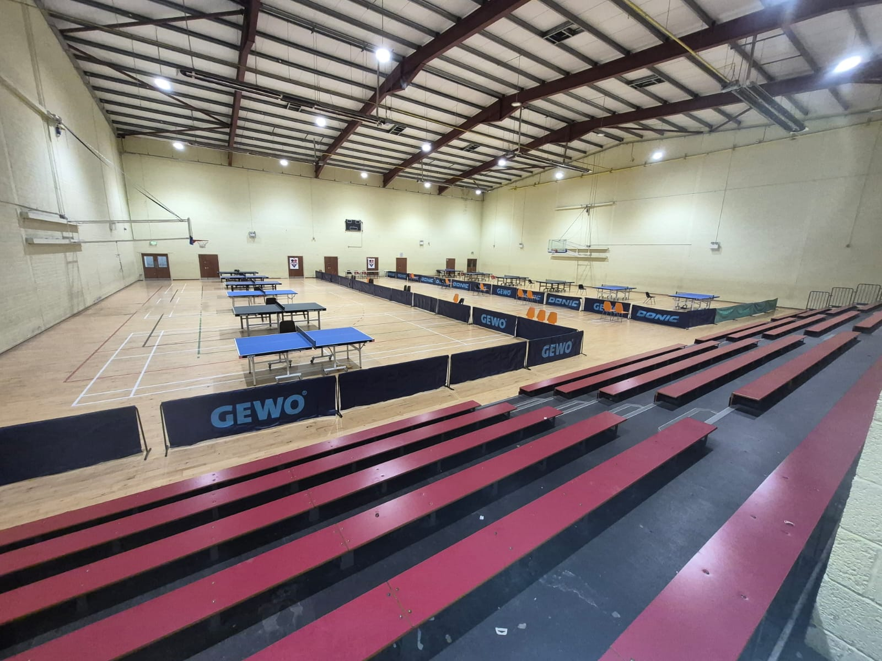

Event Statistics
Total Entries | 87
Total Matches Played | 166
Total Sets Played | 510
Total Points Played | 9,735

Junior Events

U11 Boys
Winner: Jamie Yan Theunissen (Leeside)
Runner-up: Lachlan Walsh (TTStars Waterford)
3rd: Cian Long (Beech Hill)
U11 Girls
Winner: Victoria Sawecka (Leeside)
Runner-up: S. Sathishkumar (Carrigtwohill)
U13 Boys
Winner: Olaf Chmielewski (Killarney)
Runner-up: Jayden Yan Theunissen (Leeside)
Joint 3rd: Jamie Yan Theunissen (Leeside), Syed Taha Ahmed (Beech Hill)
Plate Winner: Finn Burns (Beech Hill)
Plate Runner-up: Yonny Kekov (TTStars Waterford)
U13 Girls
Winner: Victoria Sawecka (Leeside)
Runner-up: Victoria Junyszek (Beech Hill)
3rd: Samanta Pusinskaite (Leeside)
U15 Boys
Winner: Gabriel Corzo (Leeside)
Runner-up: Jayden Yan Theunissen (Leeside)
Joint 3rd: Oliver Chamilla (TTStars Waterford), Olaf Chmielewski (Killarney)
Plate Winner: Matthew Geary (TTStars Waterford)
Plate Runner-up: Lucas Walsh (TTStars Waterford)
U15 Girls
Winner: Samanta Pusinskaite (Leeside)
Runner-up: Victoria Junyszek (Beech Hill)
3rd: Alvina Klochan (TTStars Waterford)
U19 Mixed
Winner: Martin Burke (TTStars Waterford)
Runner-up: Kevin O’Callaghan (Beech Hill)
Joint 3rd: Ronan Geary (TTStars Waterford), Sean Buckley (Leeside)
Plate Winner: Al’vina Klochan (TTStars Waterford)
Plate Runner-up: Alon Romem (Leeside)

Senior Events

Senior Women
Winner: Caoimhe Deane (Leeside)
Runner-up: Samanta Pusinskaite (Leeside)
Joint 3rd: Alessandra Fadda (Leeside), Victoria Sawecka (Leeside)
Plate Winner: Sylwia Idec (TTStars Waterford)
Plate Runner-up: Alvina Klochan (TTStars Waterford)
Senior Men A
Winner: Igor Chamilla (TTStars Waterford)
Runner-up: Philip Shaw (Beech Hill)
Joint 3rd: Jake Kells (TTStars Waterford), Myo Chit Ko (TTStars Waterford)
Plate Winner: Piotr Sawecki (Leeside)
Plate Runner-up: Sean Buckley (Leeside)
Senior Men B
Winner: Martin Burke (TTStars Waterford)
Runner-up: Olaf Chmielewski (Killarney)
3rd: Evaldas Pusinskas (Leeside)
Para Event
Para – Mixed
Winner: Nicholas O’Brien (Beech Hill)
Runner-up: Dan Jensen (Waterford TTC)
3rd: Aoife Kelly (Beech Hill)
Veterans
Veterans – Mixed
Winner: Igor Chamilla (TTStars Waterford)
Runner-up: Philip Shaw (Beech Hill)
Joint 3rd: Chetan Rai (Leeside), Stuart Grannell (TTStars Waterford)
Plate Winner: Bernie Franklin (TTStars Waterford)
Plate Runner-up: Kieran Everett (Waterford TTC)

Medal Tables

Medal Tables — Main Categories
Club | Gold | Silver | Bronze | Total
Leeside | 6 | 3 | 7 | 16
TTStars Waterford | 4 | 1 | 6 | 11
Beech Hill | 1 | 5 | 3 | 9
Killarney | 1 | 1 | 1 | 3
Carrigtwohill | 0 | 1 | 0 | 1
Waterford TTC | 0 | 1 | 0 | 1

Medal Tables — Plate Categories
Club | Gold | Silver | Total
TTStars Waterford | 4 | 3 | 7
Leeside | 1 | 2 | 3
Beech Hill | 1 | 0 | 1
Waterford TTC | 0 | 1 | 1

Players of the Tournament

- Igor Chamilla (TTStars Waterford) — Double champion in Senior Men A and Veterans.
- Victoria Sawecka (Leeside) — Winner of U11 Girls and U13 Girls, and Senior Women medalist.
- Martin Burke (TTStars Waterford) — Champion in U19 Mixed and Senior Men B.

Closing Remarks

The Munster Branch extends sincere thanks to TTStars Waterford for the professional organisation and hosting of the fourth ranking event of the season. The smooth running of the tournament reflected the strong preparation work carried out in advance and the excellent support from volunteers on the day.
Special appreciation is extended to referee Tom Mitchell for overseeing the event, as well as to all coaches, parents, and players who contributed to a positive and competitive atmosphere throughout the day.
The standard of play across the junior and senior categories continues to improve, which is very encouraging for the ongoing development of table tennis in Munster.
With consistently strong entries and growing engagement across clubs, the Munster Ranking Series remains a key pillar of the provincial competition calendar.
The Branch looks forward to building on this momentum at the remaining events of the season.
Photos from the event will be published on the Munster Branch website in due course.

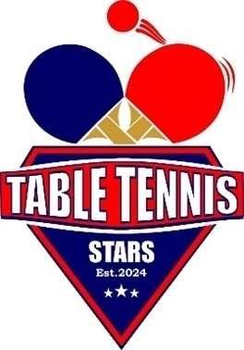 | 

