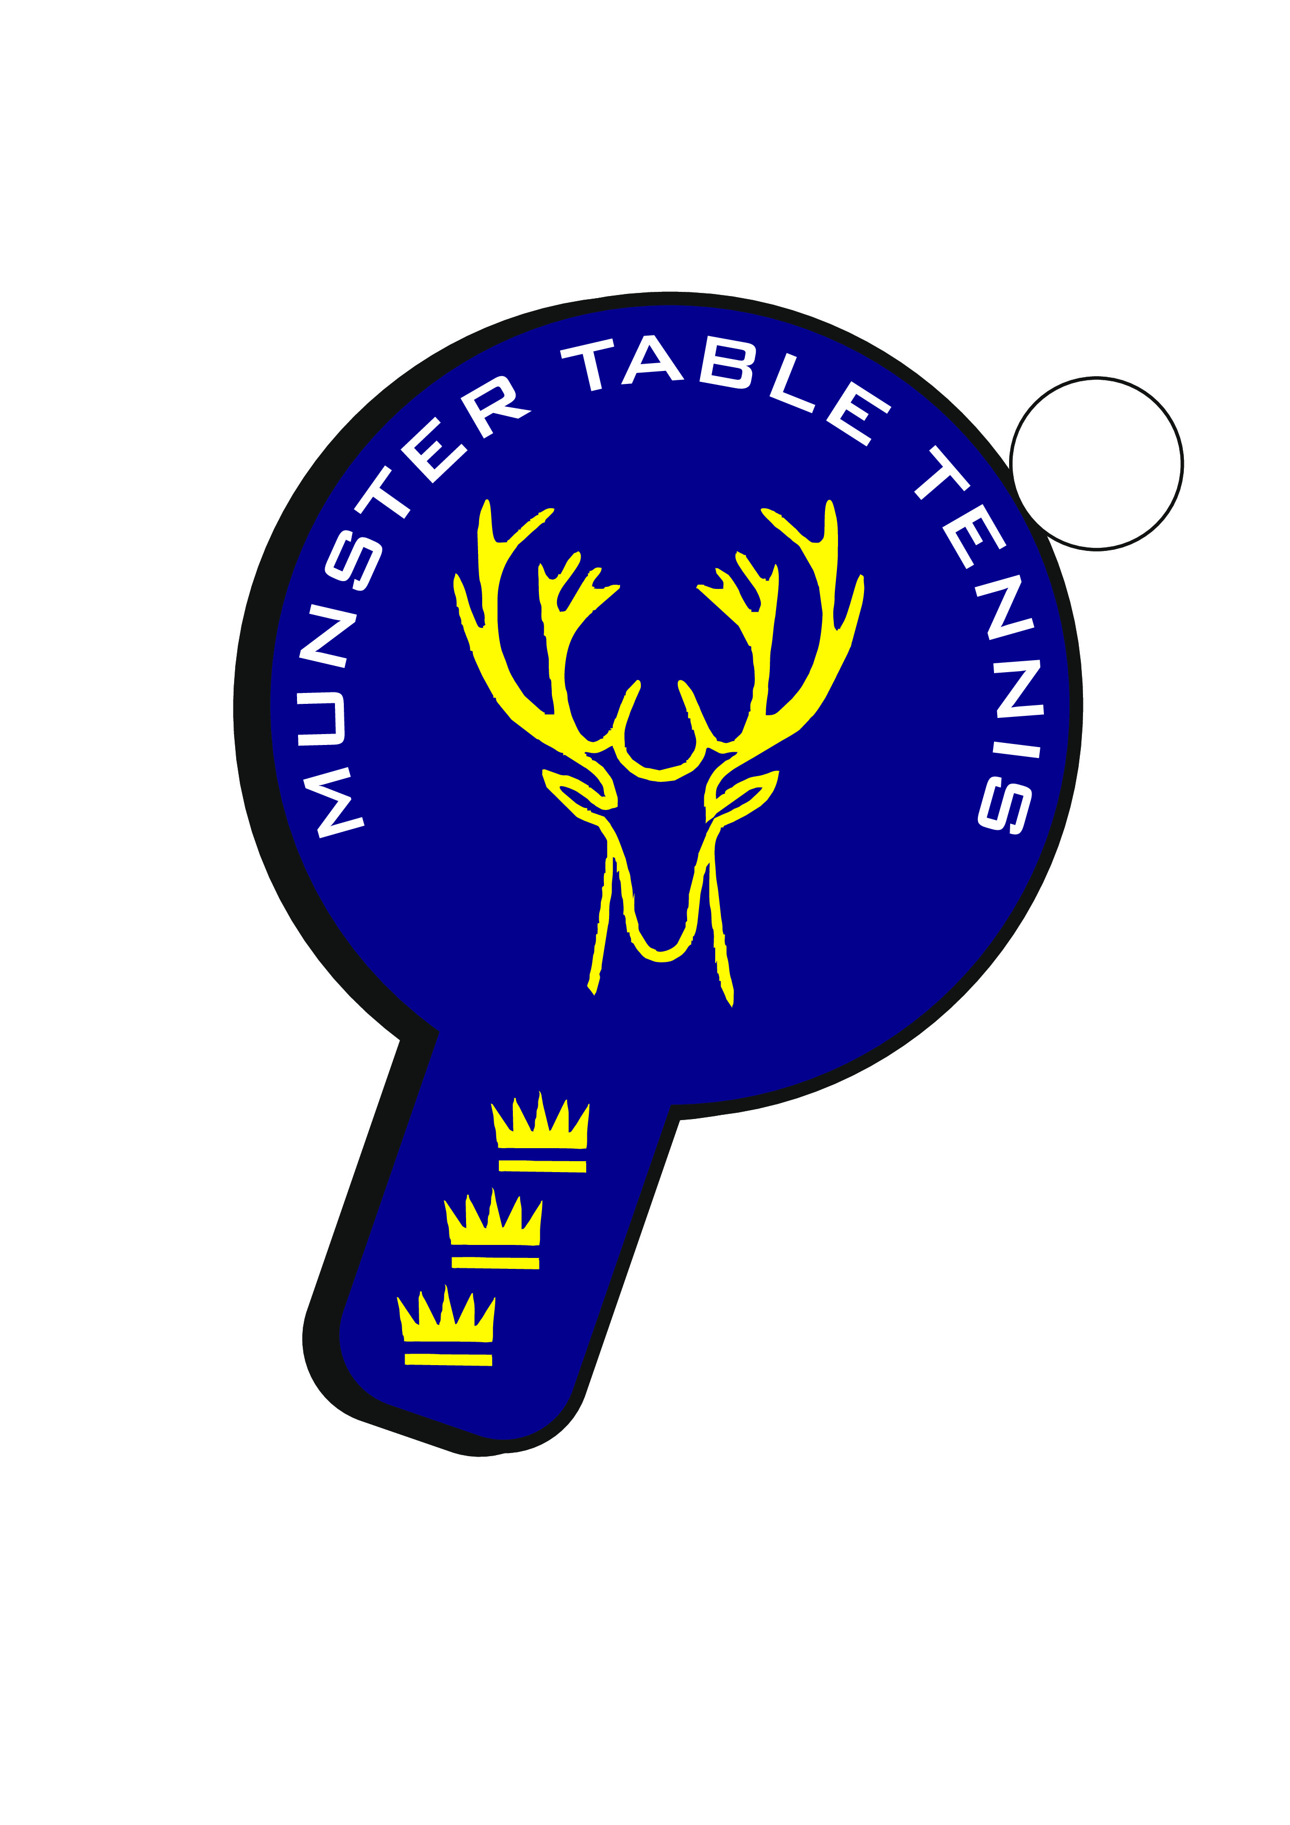

Munster Open 2026

Tournament Report

MTU Arena, Cork | 17–18 January 2026

Introduction

Munster Table Tennis was delighted to return to the MTU Arena in Cork City for the 2025/2026 Munster Open, delivering one of the most successful editions of the tournament to date.
A total of 366 entries from 156 players were received across 17 competition categories, representing a 100% increase in both player numbers and total entries compared with the 2023/2024 Munster Open. This outstanding growth reflects the continued momentum and enthusiasm for competitive table tennis within Munster and across the country.
As part of Munster TT’s ongoing commitment to inclusion and participation, a dedicated event was again provided for members of the Parkinson’s Ireland Association, reinforcing the Open’s role as a truly inclusive sporting occasion.

Participation Highlights
The largest categories were:
• Senior Men’s Singles – 60 entries
• Restricted Singles – 55 entries
• U21 Men’s Singles – 33 entries
• U17 Boys Singles – 32 entries
The largest female category was the Women’s Singles, with 16 entries received.

Tournament Schedule & Match Volume

With 768 matches, 2,493 sets and 45,977 points played across the two days, the Munster Open operated at an exceptionally high competitive volume.
As a result of this unprecedented level of activity, both days concluded slightly later than originally scheduled. Munster TT would like to thank players, coaches, officials and volunteers for their patience and cooperation throughout the weekend. The successful completion of such a high number of matches, sets and points reflects both the scale of the event and the commitment of everyone involved.

Results & Performances
Outstanding performances included:
Munster Open 2026 - Player of the Tournament
• Anjali Singh (Ormeau TTC) – Senior Women, U21 Women and U19 Girls Champion
• Alex Lo (Ormeau TTC) – Senior Men and U21 Men Champion
• Christopher Allsop (Ormeau TTC) – U19 and U17 Boys Champion
• Lea Gal (Ormeau TTC) – U17 and U15 Girls Champion
Ormeau TTC finished as the leading club with ten titles, followed by Leeside TTC with four.
Ulster finished as the leading province with ten titles, followed by Munster with five and Leinster with two titles.

Live Streaming & Media
Live streaming across both days added significantly to the spectator experience.
Munster TT would like to sincerely thank Sean McKinley for volunteering his time and expertise to deliver the coverage.

Officials, Volunteers & Event Delivery
Munster TT extends its sincere thanks to John Stalker, Tournament Referee, for his official oversight of the event.
Special recognition is due to Niall O’Flaherty for managing Top Table operations, coordinating daily draws, scheduling and category flow, and playing a central role in the real-time delivery of the tournament.
Daniel Kovac from the Munster Branch oversaw Top Table coordination and Tournament Software management, ensuring live results, category progression and effective communication between officials and the control desk throughout the weekend.
Munster TT acknowledges the contribution of the Munster Committee, event officials and volunteers whose collective effort supported the successful delivery of the Munster Open.

Sponsors & Support
Munster TT sincerely thanks all tournament sponsors whose support made the Munster Open 2026 possible.
Gold Sponsor:
Indaver
Silver Sponsors:
Barefoot Physio
Neville Jewellers
Cork Sports Partnership (Sport Ireland)
Radisson Blu Hotel, Cork
Bronze Sponsors:
Gerald McCarthy Gifts & Awards
Move It 4U
Celtic Table Tennis

Trophies, Prizes & Presentation
Munster TT congratulates all winners and medallists and acknowledges the effort involved in preparing and presenting the trophies and prizes.

Looking Forward
TTI will shortly circulate a player feedback survey and Munster TT encourages all participants to share their views in order to help further improve the Munster Open experience in future seasons.
The continued growth in participation, competitive standard and spectator engagement at the Munster Open 2026 provides a strong foundation on which to build. Munster TT remains committed to delivering high-quality, inclusive and well-organised events that support player development across all age groups and competition levels.
Munster TT would like to thank again all players, coaches, clubs, officials, volunteers and sponsors for their contribution to the success of this year’s tournament, and looks forward to welcoming the table tennis community back again for an even stronger Munster Open 2027.

Munster Open 2026 – Category Winners
The following table lists the official category winners from the Munster Open 2026.
https://www.tournamentsoftware.com/sport/winners.aspx?id=ee279a8d-f7c5-4c6a-b323-79270048f768
Category | 1st Place | 2nd Place | Semifinalists
U11 Boys | Jamie Yan Theunissen | Syed Taha Ahmed | Rudra Ramji,  PJ Rooney
U11 Girls | Victoria Sawecka | Julia Petlytska | S. Sharthishree,  Zilin Wang
U13 Boys | Daniel Daly | Jayden Yan Theunissen | Enoch Huang,  Jamie Yan Theunissen
U13 Girls | Samanta Pusinskaite | Victoria Sawecka | Anna Matveyeva,  Victoria Junyszek
U15 Boys | Karsten Close | Daniel Daly | Adam Hedderly,  He Ming Duan
U15 Girls | Lea Gal | Samanta Pusinskaite | Jane Wilson,  Emma O’Callaghan
U17 Boys | Christopher Allsop | Toby Caldwell | Aaditya Singh,  Ryan Li
U17 Girls | Lea Gal | Jane Wilson | Miranda Parra Escalona, Polly Smith
U19 Boys | Christopher Allsop | Toby Caldwell | Jack Bailie,  Daniel Patterson
U19 Girls | Anjali Singh | Lily Parke | Caoimhe Deane,  Miranda Parra Escalona
U21 Men | Alex Lo | Ryan Li | Toby Caldwell,  He Ming Duan
U21 Women | Anjali Singh | Lily Parke | Caoimhe Deane
Senior Men | Alex Lo | Christopher Allsop | Toby Caldwell,  Igor Chamilla
Senior Women | Anjali Singh | Claire Heller | Sabina Devereux,  Zofia Wawrzyniak
Para | Paddy Vaughan | Seán Geoghegan | Aaron Mellows,  Colin Judge
Restricted Singles | Alex Melikov | Jack Bailie | Stuart Grannell, Siddeswara Prasad H R
Veterans | Igor Chamilla | Anthony Redmond | Sylwester Hajdul,  Wai Tat Sum

Full match details and draws remain available via Tournament Software.

Munster Open 2026 – Visual Highlights


Full photo gallery available on the Munster website.

