

Munster Open 2026
Competition Information



Event Details

Dates: Saturday 17 & Sunday 18 January 2026
Venue: Munster Technological University (MTU) Arena, Bishopstown, Cork City
Eircode: T12 ERX0
Irish Ranking Tournament – Class 2
Referee: TBC

Venue Information

The MTU Arena is located on the campus of Munster Technological University (MTU) in Bishopstown, Cork City. Access to the Arena is via the main entrance on Melbourn Road, which can be reached from Model Farm Road to the north or Curraheen Road to the south. After entering the campus, follow the signs for the Arena.
Ample parking, including wheelchair parking spaces, is available on both the southern and western sides of the Arena building.
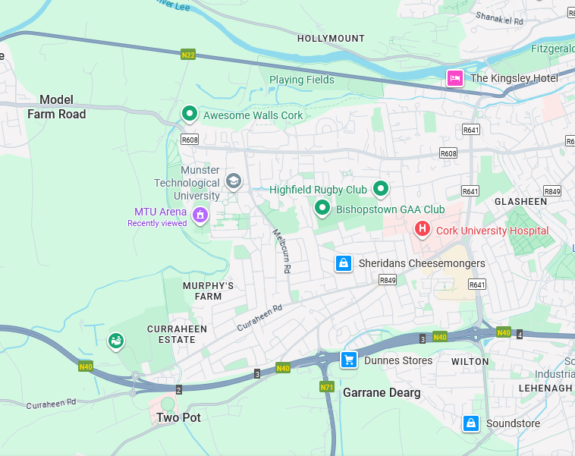

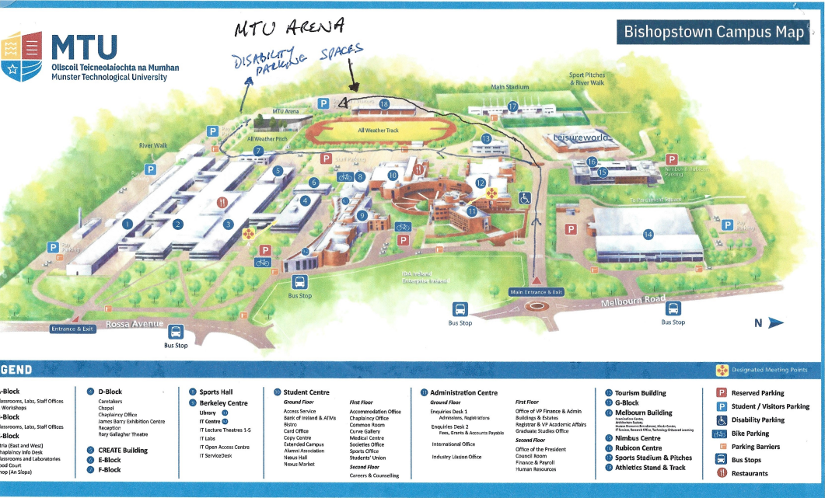

Provisional Schedule of Events & Start Times

The schedule below is provisional and subject to change, depending on entry numbers in each event. Please check the Table Tennis Ireland website (www.tabletennisireland.ie) for any updates closer to the event.

Saturday 17 January
• Senior Men & Women – 9:00 am
• Para – Class 1–5 / Class 6–10 / Class 11 – 12:30 pm
• Veterans – 1:30 pm
• U/21 Men & Women – 1:30 pm
• Restricted Singles – 3:30 pm

Sunday 18 January
• U/19 Boys & Girls – 9:00 am
• U/15 Boys & Girls – 9:00 am
• U/11 Boys & Girls – 10.00 am (to be combined if low on Girls’ entry)
• U/17 Boys & Girls– 1:00 pm
- U/13 Boys & Girls – 1.00 pm
• Parkinson’s Singles – 2:00 pm
Due to the uncertain nature of entries in national ranking tournaments, the timetable and categories above are subject to change following receipt of entries. Please watch the Table Tennis Ireland website (www.tabletennisireland.ie) for updates.
Should entries exceed the operational capacity of the venue, the organising committee reserves the right to restrict or close entries in specific categories.
Entry & Fees

Entries must be submitted via the Table Tennis Ireland website using the JustGo system.
Closing Date for Entries: 5:00 pm on Friday, 9 January 2026.
Event Category | Senior Fee (€) | Junior Fee (€)
Men’s / Women’s Singles | 30 | 20
Veterans Singles | 30 | –
U/21 Singles | 30 | 20
Restricted Singles | 30 | 20
Para Singles | 30 | 20
U/11 Singles | – | 15
U/13 Singles | – | 20
U/15 Singles | – | 20
U/17 Singles | – | 20
U/19 Singles | – | 20
Parkinson’s Singles | Free | –

Combination entries with discount pricing will be available for entries made through the Table Tennis Ireland website.
Event Formats (Subject to Entry Numbers)

Senior Singles Events
Events will be played in groups followed by knockout. The top two players in each group will qualify for the knockout stages. Up to eight top seeds in Men’s Singles and up to four top seeds in Women’s Singles may be seeded directly into the knockout stage, at the discretion of the Referee.
Para & Junior Events (U/19, U/17, U/15, U/13, U/11)
These events will normally be played in first-round groups, with the top two players in each group advancing to the knockout stage and the remaining players progressing to a Plate event. Where entry numbers allow, a format of groups into groups into knockout may be used. Playoffs will take place where possible. Depending on entry numbers, up to four top seeds may receive a bye to the knockout or second-round stage, at the discretion of the Referee.
Restricted Singles
The Restricted Singles event is not open to players ranked in the Top 20 Men or Top 10 Women in Ireland (or equivalent standard), as determined at the discretion of the Referee.

Event Information & Player Responsibilities

Table Tennis Ireland, the Management Committee and the Munster Branch request the cooperation of all clubs and entrants in ensuring a well-run and enjoyable tournament. Please note that there will be a limited number of official umpires at the event; players will be expected to umpire matches in accordance with the tournament regulations.
Event start times, check-in times and any arrival time limitations will be published on the Table Tennis Ireland website in advance of the tournament. Players should not arrive at the venue ahead of the times stated on the website and may not be permitted to remain in the hall outside their own event times.
Groups and match times will be posted on the Table Tennis Ireland website approximately two days before the tournament. All players and coaches are strongly advised to check that all entries are correctly listed in the appropriate events.
3-star plastic orange balls will be used at this event.
Prizes

Prize money will be awarded in the following events:
• Men’s Singles
• Women’s Singles
• Restricted Singles
• U/21 Boys & Girls
• Veterans Singles
Trophies or medals will be awarded in all other events.

Tournament Regulations

• No late entries will be accepted (as per Table Tennis Ireland policy).
• No refunds will be paid after entries have been entered into the draw format.
• Players may not enter two events that start at the same time.
• Players may enter a maximum of four singles events.
• Maximum entry numbers may apply in certain events. Where numbers are capped, the general rule of ‘last in = first out’ will apply. If necessary, entries may also be restricted or rejected based on ranking.
• Date of Birth (DOB) is required for all age-restricted events:
– U/11: on or after 01 January 2015
– U/13: on or after 01 January 2013
– U/15: on or after 01 January 2011
– U/17: on or after 01 January 2009
– U/19: on or after 01 January 2007
– U/21: on or after 01 January 2005
– Veterans: 39 years and over on 01 January 2026
• No refunds will be given to players who enter events for which they are not eligible. Please check your entry carefully.
• All matches will be played in accordance with the Rules and Regulations of Table Tennis Ireland and the ITTF.
• All competitors must be affiliated to Table Tennis Ireland. An affiliation check will be carried out by Table Tennis Ireland prior to the event.
• Players may be scratched if they are not present and ready to play when called upon. Check-in time is 30 minutes before the start of a player’s first event.
• All competitors will be required to umpire as directed by the Referee or organisers.
• The draw will be seeded in all main events. Byes may be allocated in Senior Singles and in age-group events as per Table Tennis Ireland regulations.
• Matches will generally be played as best-of-5 games (first to 3 games). Early round Plate matches may be played as best-of-3 games, at the discretion of the Referee.
• Group standings will be determined according to ITTF Regulation 3.7.5 for group competitions.
• The decision of the Referee is final on all points of law and in all cases of dispute. The decision of the umpire is final on all points of fact.
• Due to the two-day format, time between playing rounds will be condensed. Players should expect to play rounds in quick succession.
• No coaching or time-outs are allowed in the U/11 events.
• In U/13 events, a designated coach must be named at check-in.

Photography, Video Recording & Live Streaming

In line with the Table Tennis Ireland Data Protection Policy, which covers the use of photographic and video recording equipment at TTI events, permission for the use of such equipment must be sought from the Referee or the Organizing Committee.

By entering this tournament, all participants accept that photographs or other recorded images (including live streaming), taken on behalf of Table Tennis Ireland, may be used in connection with the promotion of TTI events and activities. In the case of underage players, consent may be withheld. Withdrawal of consent for underage players must be requested in advance from TTI by the participant, their parent/guardian or their coach.

Anti-Doping

Doping control tests may take place at this event. Further information on anti-doping is available on the Table Tennis Ireland website: https://tabletennisireland.ie/anti-doping/

Table Tennis Ireland Single Event Membership

Table Tennis Ireland has introduced a Single Event Membership Licence fee of €6.50 for Juniors (U/19) and €11 for Seniors. This allows players to compete in one Irish tournament without paying the full annual affiliation fee.

Disclaimer

Table Tennis Ireland, including its Branches, Leagues, Committees and affiliated bodies, reserves the right to cancel, postpone, discontinue or amend any part of this tournament at any time and for any reason. In such circumstances, the liability of Table Tennis Ireland shall be strictly limited to a refund of entry fees already paid by the affected entrants.

Table Tennis Ireland does not accept responsibility or liability for any associated or consequential losses, including but not limited to travel, accommodation or subsistence costs incurred by players, coaches, spectators, officials, members of the media or any other attendees.

By submitting an entry for this tournament, all participants acknowledge and accept these terms and conditions in full.

Accommodation Information – Radisson Blu Hotel, Little Island

Munster Table Tennis has secured a discounted room rate with the Radisson Blu Hotel, Little Island, Cork City (Eircode: T45 WF53), based on a group booking of over 10 rooms. A total of 40 rooms have been reserved.
Indicative room rates (B&B, per room per night):
• €115 – Single (1 adult)
• €129 – Twin or Double (2 adults)
• €139 – 2 adults and 1 child (rollaway bed or baby cot)
• €149 – 2 adults and 2 children (bunk beds)
• €169 – 2 adults and 3 children (bunk beds plus single bed)
• €210 – Interconnecting rooms (one double room and one twin room; up to 4 adults or 2 adults and 3 children)
Three-course dinner menus are available from €40.00 per person.
To book, please contact the hotel directly on 021 4297000 and mention “Table Tennis 2026” to receive the discounted rate.
To help Munster Table Tennis monitor uptake of the allocation, please email Munster TT at munterttinfo@gmail.com once you have made a reservation.
The hotel is located on the east side of the Cork City area. For access to MTU Arena, it is recommended to travel via the N40 and the Jack Lynch Tunnel, exiting at Junction 2 (Bishopstown/Curraheen) and following signs for MTU.
