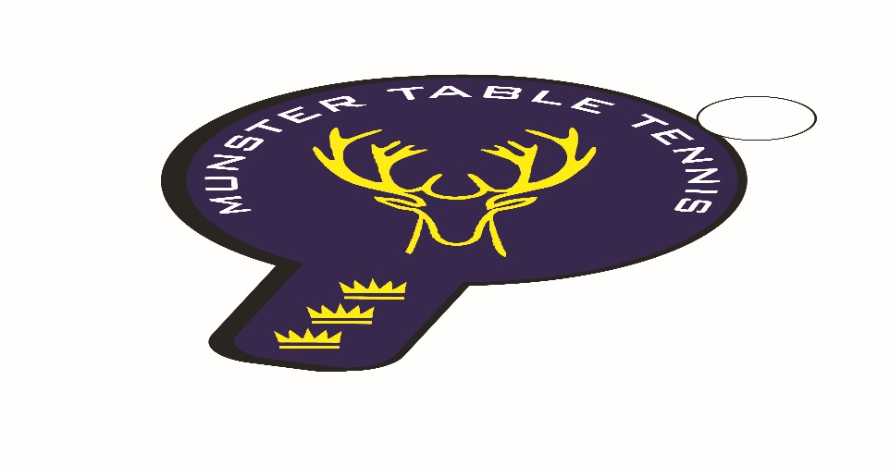
Munster Ranking Competition No 3 – 14 December 2025
Competition Report
A small entry was received for event no 3, which was held in Knocknaheeny, Cork City. A total of 73 entries from 47 players was taken, not surprising perhaps with the proximity of Christmas and the early appearance of the flu season. We had players from 4 counties – Cork, Kerry, Waterford and Wexford– with 6 different clubs contributing players. The following categories were offered –U/11, U/13, U/15, U/19,Para, Veterans, Senior Men’s Divisions 1 and 2 and Senior Women’s Division. We were delighted to see Performance Coach, Conn Higgins, in attendance, no doubt assessing the performance of players with the Inter Pro Championships in mind next year.
But what an event for our female players! For the first time in living memory the largest single category of entries for a ranking competition was the Senior Women’s Division; we had the unique experience of seeing a mother and daughter squaring off for a final match in the Senior Women’s Plate; and the Player of the Tournament was, undoubtedly, 10 year old Victoria Sawecka from Leeside who achieved 3 victories including, amazingly, the Senior Women’s Division. Heads were scratched about that achievement not least about whether Victoria is the youngest ever senior division winner in Munster. Answers on a post card to Munster TT please!

Igor Chamilla of TT Stars Waterford prevailed in the Senior Men’s Division 1 final by beating Philip Shaw, Beech Hill. Mariusz Chmielewski of Killarney defeated Conall Conroy of Leeside in the Plate final. The Men’s Division 2 final was won by Gustavo Polli of Leeside beating fellow club mate Jayden Theunissen, while Oliver Chemilla of TT Stars won the Plate final beating Evaldas Pusinskas of Leeside. As mentioned above, young Victoria Sawecka of Leeside won the Senior Women’s Division defeating fellow Leesider, Alessandra Faddo, in the final. In the Plate final we saw a memorable mother and daughter combination with Malgorzata Jankowska of Beech Hill defeating her daughter Victoria Junyszek, also of Beech Hill. In the Veterans we had a repeat of the Men’s Division 1 final with Igor Chamilla again defeating Philip Shaw in the final. In the Para event newcomer Lucas Walsh of TT Stars Waterford defeated Aoife Kelly in a round robin group.
In the Junior categories, Ronan Geary, TT Stars, Waterford, defeated Kevin O’ Callaghan of Beech Hill, in the U/19 Mixed category final. The U/19 Plate was won by Saad Idar, unattached, defeating Martin Burke of TT Stars. In the U/15 categories, Syed Taha Ahmed of Beech Hill defeated Jayden Theunissen of Leeside in the Boys, with Saad Idar, unattached, beating Lucas Walsh, TT Stars, in the Plate. In the Girls competition, Samanta Pusinskaite, Leeside, won the U/15 Girls in a round robin group, with Emma O’Callaghan Beech Hill second. At U/13 level, the Boys final was won by Jayden Theunissen of Leeside who defeated Olaf Chmielewski. Killarney, while Mickus Versis , unattached, beat Finn Burns of Beech Hill to win the Plate final. The U/13 Girls competition was won by, guess who, Victoria Sawecka , Leeside, in a round robin group with Samanta Pusinskaite of Leeside second. Jamie Van Theunissen of Leeside won the Boys U/11 final defeating newcomer Lachlan Walsh of TT Stars in the final, while that girl again, Victoria Sawecka of Leeside, was the U/11 Girls winner.
Overall, a hugely successful tournament for Leeside with 7 winners – congrats to coaches Ben Haughton and Gary Mahoney. TT Stars were second with 4 wins and Beech Hill with 1 victory. Notable performances alongside Victoria Sawecka were Igor Chamilla of TT Stars with double victories in the Senior Men’s and Veterans Divisions, the Theunissen brothers Jamie and Jayden of Leeside for their double in the U/11 and U/15 Boys events respectively.
The next Munster TT competition is the big one – the Munster Open – a national level 2 championship to be held in the MTU Arena, Cork on 17/18 January. Details are posted on the Munster TT and TTI website. The next ranking event is scheduled for Waterford in February – details to follow.

