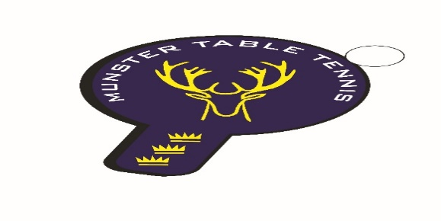

**Munster Branch, Irish Table Tennis Association**

**Annual Report 2024- 2025 Season**

**Executive Committee**

6 Committee meetings were held during the season with an average attendance rate for all members combined at 76% - this figure reflects the fact that one Committee member did not attend any meetings during the season. Meetings with external agencies such as Munster Special Olympics, Cork Sports Partnership, Limerick Sports Partnership, Tipperary Sports Partnership and Waterford Sports Partnership were held also.

**Primary Strategic Themes – Progress Report Phase 1**

Participation & Sport Development

Affiliated membership growth – 219 for season - up 300+% on 2023/24 season

Gender balance – 24% Female members and 76% Male members – female membership has increased by 4% from the 2023/24 season.

Active Schools growth. A total of 10 primary schools participated in invitational events held in Cork during the season while in the All-Ireland Qualifier Competition 6 primary schools and 4 secondary schools from 3 counties participated, which represents a 67% increase in the number of schools involved. A total of 91 players took part which was a slight drop on last year but there was an increase of 5% in the numbers of female participants. The Munster schools programme has been ably assisted by the visits to Cork, Limerick and Waterford schools by Jing Yi Graham where she has delivered Activator Award, Her Moves and Junior leader programmes during the season. These programmes have been delivered in partnership with the local sports partnerships in these counties. A total of 10 schools programmes were delivered in Cork with 2 programmes in Limerick and 1 in Waterford. A total of 3 Activator Award courses were run in Cork.

New to table tennis programmes. Supported by Cork Sports Partnership 4 “Come and Try” sessions were provided to beginners and returning players during the season. Munster TT also delivered a special” Come and Try” programme with members of the Cork Parkinsons’ Branch and was represented at an Open Day for My Active Brain which was aimed at people with neurological conditions.

Inclusion. Three Para Squad training camps completed during the season. In partnership with Munster Special Olympics two blitzes for Special Olympics clubs in Munster were delivered. The mixed ability participation model continues to be developed - Beech Hill, Cork has now affiliated to the Mixed Ability Sports International association and funding will be sought by TTI from Dormant Account funding to roll this club model out across the provinces in 2026.

Club Development. New club development completed in East Cork with the Carrigtwohill Club. Development is underway in Cobh, Co Cork and Ballinlough, Cork City. Discussions ongoing with Tipperary Sports Partnership re club development in Thurles. TT Stars Waterford have expressed an interest in working closely with Waterford Sports Partnership to develop a hub in West Waterford and will be supported by Munster Branch to do so in the coming season.

Brilliant Events

Sadly, there was no Munster Open held in 2025 due to insufficient funds and the probability of making a significant loss. It is financially unsustainable to be using venues of the standard required by TTI for national level tournaments in the future unless some form of financial response is forthcoming pre-season e.g. an upward review of entry fees, sponsorship to name a couple of options. For the first time, in a number of years, the Munster Veterans Championships were hosted by Munster TT in Cork. It had been hoped that Munster TT would host the 2025 Inter Provincials in Cork, but this was not the case, Munster entered an increased number of teams for the 2025 Inter Provincials and saw an improved team performance with 2 silver medal finishes for the Veterans and Mini Cadet Girls teams respectively.

Ranking Events:

22 Sept – Beech Hill/Leeside - 65 entries

13 Oct – Beech Hill/Leeside – 89 entries

13/14 Jan – Beech Hill/Leeside – 88 entries

16 Feb – South Coast – 54 entries

09 Mar – Beech Hill/Leeside – 32 entries (Junior and Para categories only)

Building Profile

Sponsorship. No success with regard to a number of approaches to companies for sponsorship of the Munster Open. Sponsorship for our Inter Pro teams was more successful and may lay the ground for future success in respect of the 2026 Munster Open.

Organisational Strength & Capacity

Regional Development Officer. Two attempts made to recruit, both of which failed after successful applicants subsequently turned down the job offer. A temporary filling of the post until the end of the year has been put into effect, with the appointment of Conn Higgins in the role.

Gender Balance in Committee. New Committee for the 2025/2026 season has an increase to 22% female representation.

Coach/Official/Volunteer Development. Level 1 coaching course planned for Autumn 2025.

Executive Committee for 2025/26 Season:

Chairperson: Emma Geary

Secretary: Daniel Kovac

Treasurer: Stuart Granell

Member: Eoin Kelly – Safeguarding Officer/Para Rep/Website Admin and Projects

Member: Ben Haughton – Performance (Coaching/Competitions) and Schools.

Member: Declan Conroy – Fundraising/Sponsorship and Projects

Member: Philip Shaw – Participation Coaching

Member: Gary Mahoney – Participation Coaching

Member: Catherine Morrissey - Projects

Finally, the Munster Executive Committee would like to acknowledge the passing of Bill Power, Tramore , Waterford on 3 April last. Bill was a stalwart of the game in the Southeast of the country for many years and had been involved in the recent setting up of the SETU Arena Club in Waterford and played also with the TT Stars Waterford Club alongside his two grandsons, Ronan and Matthew. May he rest in peace.

Eoin Kelly,

Chair, Munster Branch Executive Committee 2024/2025