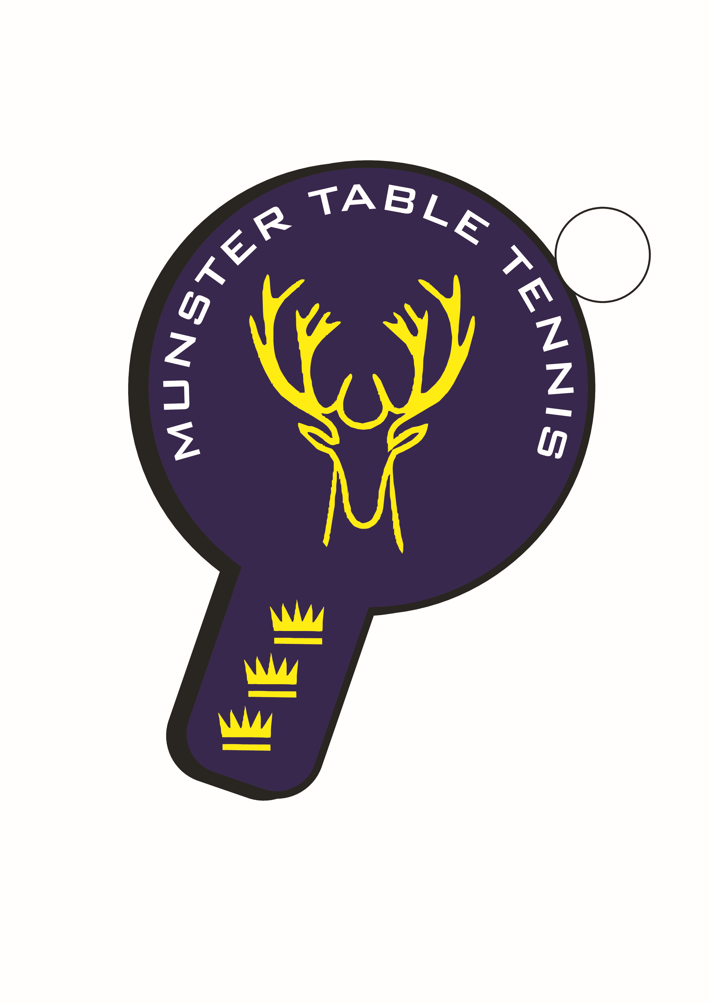

Munster TT Inter Provincial Competition Squad 2025

- Senior
Sylwester Hajdul (Beech Hill)
Stuart Granell (TT Stars)
Ben Loughnane (South Coast)
Alessandra Fadda (Leeside)
Caoimhe Deane (Leeside)

- Veterans
Piotr Stankiewicz (South Coast)
Igor Chamilla (TT Stars)
Philip Shaw (Beech Hill)
Catherine Morrissey (SETU Waterford)

- Para
Kevin O’Callaghan (Beech Hill)
Patrick McCormick (Beech Hill)
Aoife Kelly (Beech Hill)

- U/13 Boys
Syed Taha Ahmad (Carrigtwohill/Beech Hill
Alon Romen (Leeside)
Stepan Suprun (Leeside)

- U/13 Girls
Samanta Pusinskaite (Leeside)
Emma O’Callaghan (Beech Hill)
Julia Petlyska (Leeside)

- U/15 Boys
Kevin O’Callaghan (Beech Hill)
Sean Buckley (Leeside)
Oliver Chamilla (TT Stars)

- U/19 Boys
Conall Conroy (Leeside)
Martin Bourke (TT Stars)
Ronan Geary (TT Stars)

