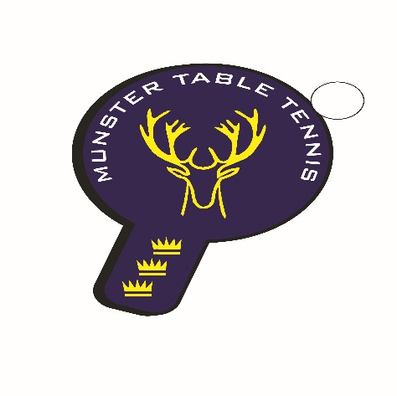
Munster TT Secondary Schools Participation Tournament 2025

Munster Table Tennis invites secondary schools to participate in a free participation tournament which will be held in the Terence MacSwiney Sports Hall, Cork on 6 March.
Start Time: 10am
Approximate Finish: 2pm
Venue: Terence MacSwiney Sports Centre, Holly Hill Lane, Cork TA23W880 (Eircode app only)
The tournament will be run in a league format in order to promote an increase in games between schools and players and generate extra participation on the day.
Each school is invited to enter one team of six players in each of the following categories – U/13, U/15 and U/19 – for both boys and girls.
U/13 - born on or after the 1st January 2012
U15 - born on or after the 1st January 2009
U19 - born on or after the 1st January 2006
Players must be in 1st year or higher. No mixed gender teams will be permitted. Each match consists of 6 singles and 3 doubles. The singles players and the doubles pairings, may be in any order. Competitors may only play in one team. The team order is declared before the competition begins and must remain unchanged through the day. One substitute may be used and may only play in the place of one nominated player. For categories with four teams there will be an open draw in each age group. The losing teams in each Semi-Final will play off for Third Place. If only three teams enter then there will be a “round robin” competition played on 2 tables.

Please complete the following Entry Form and Squad List and return to the Munster TT Secretary, on or before 2 pm Friday 28 February.
Further information on the event and on start times and results may be sought by emailing: tabletennismunstersecretary@gmail.com

RULES FOR THE COMPETITION

1. To be eligible to play for a school team a player must actually attend that school at the time of the league. No player may represent more than one school in any particular league.
2. A team consists of six players and a nominated substitute may be included. The rule for the use of a substitute is that the substitute must be put into the number four position in a team and all other players move up one place. Teams must be pre-entered and cannot be changed on the day.
3. The home team provides the umpire for the first match. After that each team provides an umpire alternatively.
5. The order of players on a match sheet should be in order of ability, best players first. Munster rankings apply where available.
6. These games are entered on the official score sheet. After the match the score sheet is signed by a representative of both teams.
7. Two points are awarded for each match: Two points for a win, one for a draw (If there is a tie in points the winner will be decided on the results between those teams that are tied.)
8. All players must wear rubber soled shoes, shorts and non-white tops
9. Munster TT may, if it should become necessary during schools events, modify, interpret or change a rule, or, if the circumstances warrant it, introduce a new rule.
10. Teams must be accompanied by a teacher or adult and supervision of players, who are not actually playing at a table at any time, must be provided to avoid accidents occurring and/or matches being delayed because of “missing” players.

ENTRY FORM
NB: Please fill out your Squads on the relevant Squad Lists sheet below and return with entry form to tabletennismunstersecretary@gmail.com

Teacher’s Signature_____________________________________
Or
Principal’s Signature_____________________________________

Squad Lists

U/13 Boys
Names:
1.
2
3.
4.
5.
6.
Substitute:

U/13 Girls
Names:
1.
2
3.
4.
5.
6.
Substitute:

U/15 Boys
Names:
1.
2
3.
4.
5.
6.
Substitute:

U/15 Girls
Names:
1.
2
3.
4.
5.
6.
Substitute:

U/19 Boys
Names:
1.
2
3.
4.
5.
6.
Substitute:

U/19 Girls
Names:
1.
2
3.
4.
5.
6.
Substitute:

