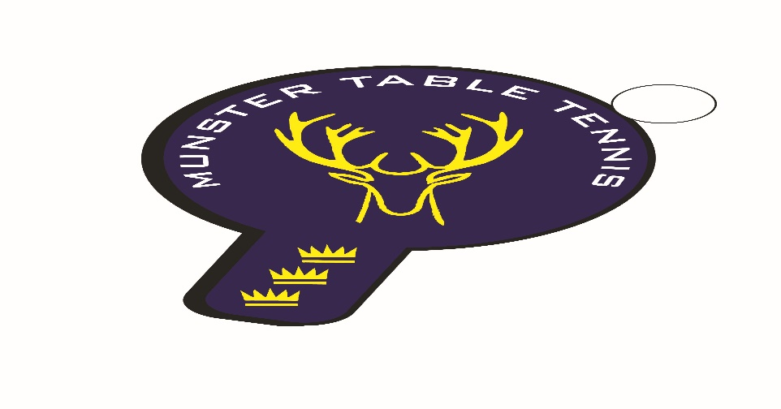
Munster Ranking Competition No 3 – 11/12 January 2025
Competition Report
A total of 92 entries from 63 players were received for the third Munster ranking competition of the 2024/25 season, which was held in Knocknaheeny, Cork City. In a break with the format for previous ranking events Munster TT reverted to the more traditional two days arrangement with the Junior categories run on the Saturday and the Senior, Veterans and Para run on the Sunday. The following categories were offered –U/11, U/13, U/15, U/19,Para, Veterans and Senior Bands 1, 2 and 3.
In the Junior categories on Saturday, the U/11 Boys was won by Taha Ahmad of Beech Hill with Stepan Suprun of Leeside second, while Finn Burns of Scoil Nioclas won the Plate. Julia Petlytska of Leeside came first in the U/11 Girls with Violetta Tymoshyna, also of Leeside, in second place. The U/13 Boys title went to Andrew Hall, unattached, who beat Taha Ahmad of Beech Hill in the final – Tom Russell, also unattached, won the Plate. The U/13 Girls event was won by Samanta Pusinskaite of Leeside beating Avina Klochan of TT Stars Waterford in the final – the Plate was won by Leeside’s Violetta Tymoshyna. In the U/15 Mixed competition Samanta Pusinskaite of Leeside won out with Sean Buckley, also Leeside, finishing second - Peter Aherne of Waterford TT Stars won the Plate. Finally, the U/19 Mixed event was won by Conall Conroy of Leeside with Ronan Geary of TT Stars Waterford finishing second – Tom Russell, unattached, won the Plate.
Sunday saw the Senior Bands, Veterans and Para category events completed. Senior Band 1 was won by Piotr Stankiewicz of South Coast beating Igor Chamilla of TT Stars Waterford in the final – Catherine Morrissey of SETU Waterford won the Plate. Band 2 was won by Joseph Joy of Leeside with Caoimhe Deane, also of Leeside, coming second – Peter Sawecki of Leeside won the Plate. Band 3 was won by Martin Bourke of TT Stars Waterford with Patrick McCormick of Beech Hill second – the Plate went to Ethan Baylis of TT Stars Waterford. The Veterans winner was Piotr Stankiewicz of South Coast who defeated Igor Chamilla of TT Stars Waterford in the final, while Faraz Sharif of Leeside won the Plate. The Para event was won by first timer Temitope Idris of Beech Hill with Kevin O’Callaghan of Beech Hill second – Nicolas O’Brien of Beech Hill won the Plate.
Overall, a very successful weekend for Leeside with five event victories, two each for Beech Hill and South Coast and one for TT Stars Waterford. The outstanding players over the weekend, undoubtedly, were Samanta Pusinskaite of Leeside, with double victories in the U/13 Girls and the U/15 Mixed events, and Piotr Stankiewicz of South Coast ,winning both the Senior Band 1 and Veterans events.
We are off to Kinsale for our next ranking competition on Sunday 16 February – full details to be found on the Munster TT website in the coming weeks – we would love to see you there!

