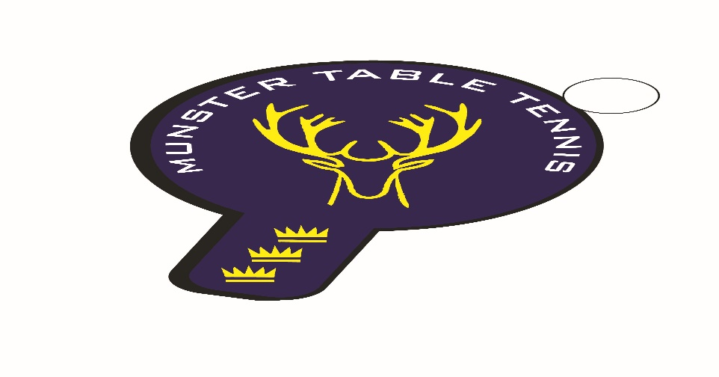
Munster Ranking Competition No 1 – 22 September 24
Competition Report
A total of 99 entries from 65 players were received for the first Munster ranking competition of the 2024/25 season, which was held in Knocknaheeny, Cork City. It was pleasing to see that the entries were an increase on last season. We had players from 3 counties – Cork, Kerry and Waterford – with 7 different clubs contributing players. The following categories were offered –U/11, U/13, U/15, U/19,Para, Veterans and Senior Divisions 1, 2 and 3.
Igor Chamilla of TT Stars Waterford prevailed in the Senior 1 Division by beating Philip Shaw, Beech Hill, in the final. Killarney’s Daniel Szabat of Killarney took the Division 1 Plate title by beating Waterford Table Tennis’ Catherine Morrissey. In Division 2 Romeo Facon of South Coast beat Kevin O’Callaghan of Beech Hill in the final while Zacherie Sold of Leeside defeated Patrick McCormick from Beech Hill in the Plate final. Division 3 saw Elliot Jackman of TT Stars Waterford win the final from Samanta Pusinskas of Leeside, while in the Plate Aoife Kelly, of Beech Hill, came first with Emma O’Callaghan, also of Beech Hill, coming second, . In the Veterans we had a repeat of the Division 1 final with Igor Chamilla defeating Philip Shaw in the final, while in the Plate final Michael Lotkowski of South Coast defeated Tomas Szpotowicz of Carrigtwohil. In the Para final Liam Hayes of Beech Hill won from Aoife Kelly, also of Beech Hill – great to see Liam back after an absence of many years. The Para Plate final was won by Nicholas O’Brien, defeating Patrick Sweeney, both from Beech Hill.
In the Junior categories, Conall Conroy defeated club mate Caoimhe Deane in the U/19 match. In the U/15s victory went to Leeside’s Sean Buckley defeating Kevin O’Callaghan of Beech Hill in the final, while Gabriel Corzon of Leeside won the Plate final from Alon Romem, also of Leeside. The U/13 Boys title went to Olaf Chmielwski of Killarney who defeated Florian Lotkowski of South Coast in the final, while Danny O’Sullivan of Killarney defeated Joe O’Sullivan of Leeside in the Plate final. The U/13 Girls competition was won by Samanta Pusinskas of Leeside from Emma O’Callaghan of Beech Hill while Julia Petlytska of Leeside won the Plate final from Violetta Tymoshyna, also of Leeside. In the U/11s Stepan Suprun of Leeside won the Boys title beating Andrew Hall, unattached, in the final with Sam Barry of Leeside picking up the Plate winner’s trophy. Emma O’Callaghan of Beech Hill won the Girls competition beating Julia Petlytska of Leeside, while the Plate final was won by Hannah from Carrigtwohill.

Overall, club honours were shared between Leeside and TT Stars Waterford with three firsts each. Our next ranking event is at Knocknaheeny, again, on Sunday 13 October – full details can be found on the Munster TT website.

